**Entity Relation Diagram**

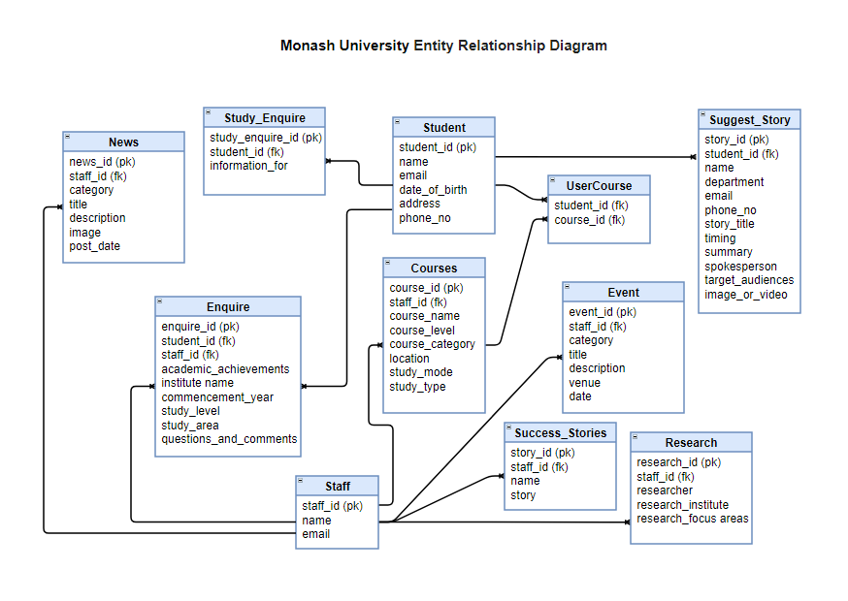

**Figure: Entity Relationship Diagram of Monash University**